INF407: Modern Issues in Databases
Assignment: 4B – Query & Tuning
Niharika Jakkula

Performance of Orginal query and explain query
Actual query runtime: 0.703sec/0.000sec
Explain Runtime: 0.016sec/0.000sec
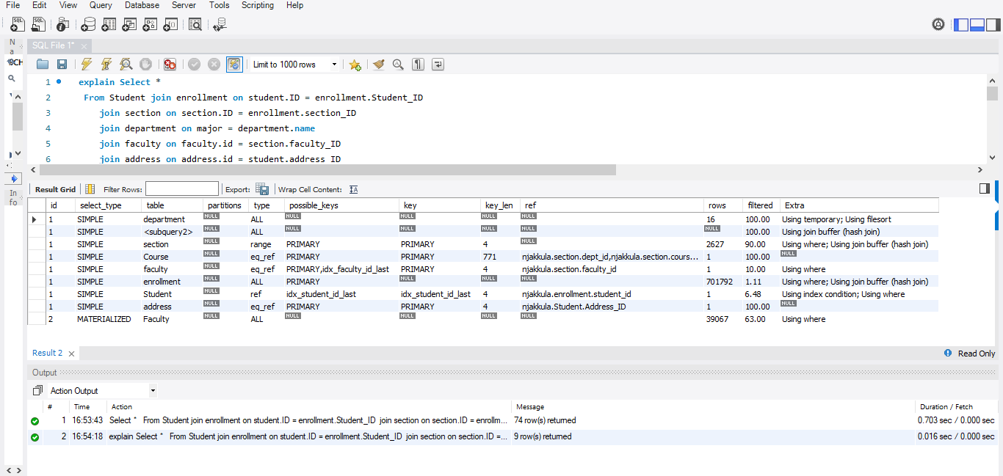
Change 1: Adding indexes
Actual query runtime: 0.078sec/0.000sec
explain query Runtime: 0.015sec/0.000sec
After creating the indexes, the EXPLAIN output showed MySQL using indexed access methods such as ref and eq_ref on multiple tables instead of full scans. This confirmed that the indexes improved join efficiency and query performance.
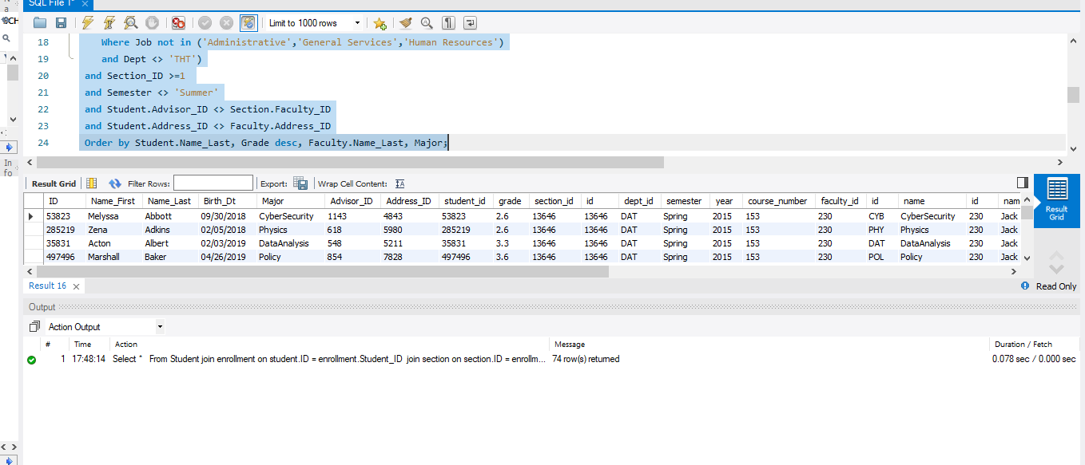
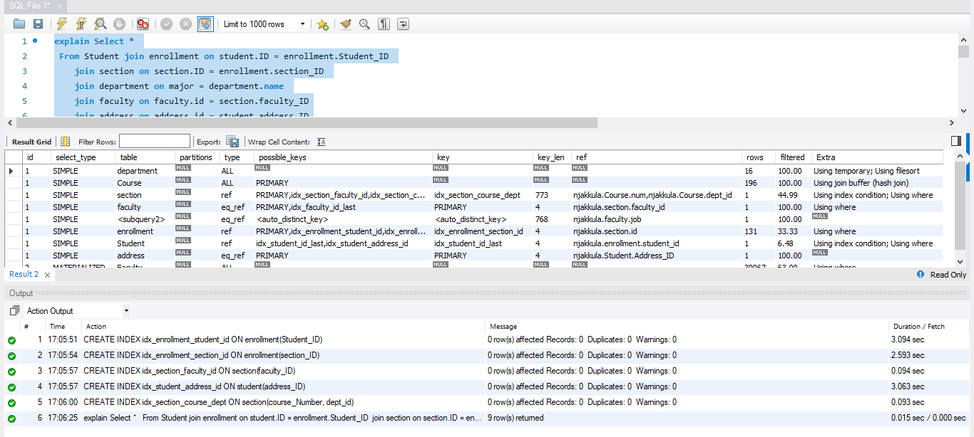
Change 2 :
Removed Unnecessary Faculty Subquery
Actual query runtime: 0.032sec/0.000sec
explain query Runtime: 0.000sec/0.000sec
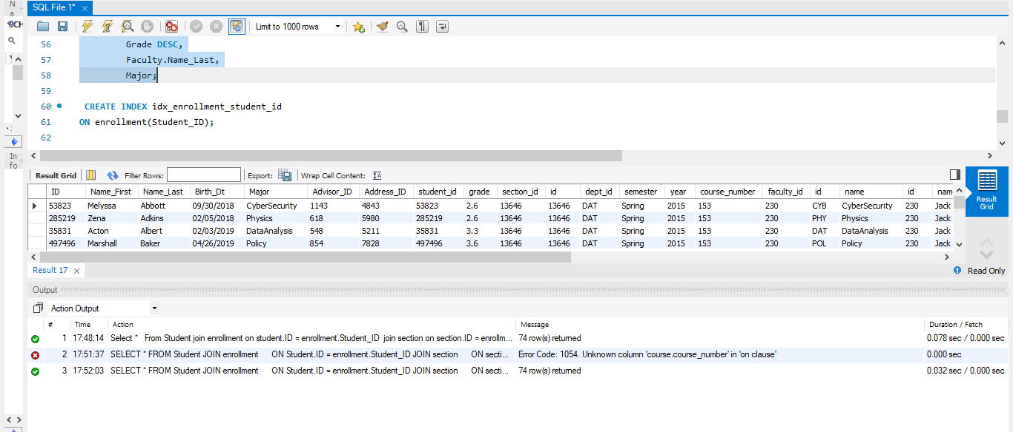
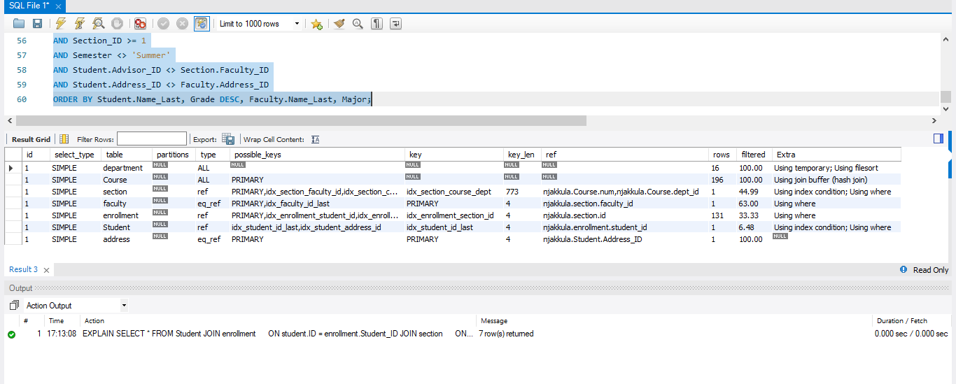
Change 3: Improved Filter Comparisons and Data Types
Actual query runtime: 0.047sec/0.000sec
explain query Runtime: 0.016sec/0.000sec
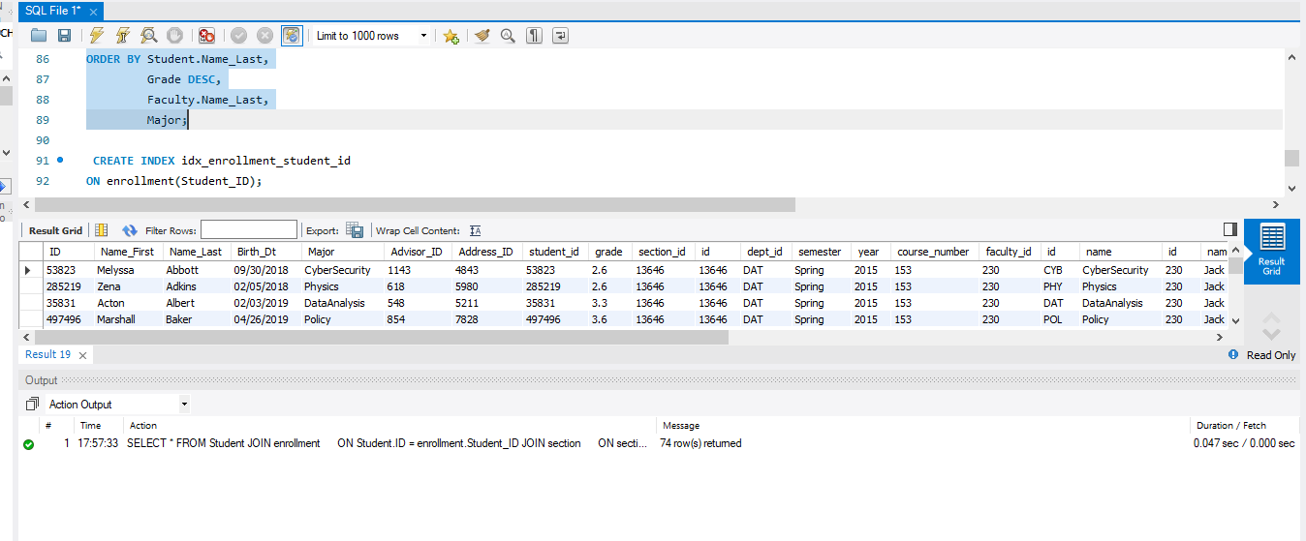

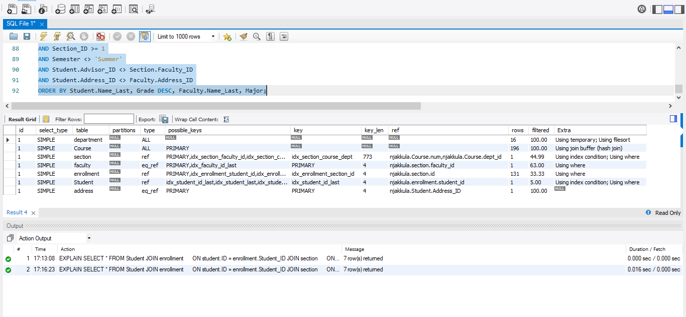

Performance of query after 3 changes
Change 1 | Change 2 | Change 3
(Added indexes on join columns) | (Removed unnecessary Faculty subquery) | (Improved filter comparisons and data types)
0.078sec / 0.000 sec | 0.032 sec / 0.000 sec | 0.047 sec / 0.000 sec

Summary:
I used the EXPLAIN command to evaluate the provided SQL query and understand how the database executed it before and after each improvement. In addition to measuring query runtime, I also ran EXPLAIN after every change to confirm whether the optimizer was using a better execution plan. The original query joined multiple tables, included a nested subquery, and sorted the results using several columns. The initial EXPLAIN output showed operations such as temporary tables, filesorting, join buffering, and a materialized subquery. These operations can reduce performance because the database may need to scan more rows and perform extra processing before returning the final results. The runtime of the original query was 0.703 seconds.
For the first change, I created indexes on the main join columns used in the query. I added indexes on enrollment.Student_ID, enrollment.section_ID, section.faculty_ID, student.address_ID, and a composite index on section.course_Number with section.dept_ID. These indexes helped the database find matching rows faster during joins instead of performing full table scans. After adding these indexes, I ran EXPLAIN again and the output showed that MySQL was using indexed access methods such as ref and eq_ref on multiple tables. The query runtime improved to 0.078 seconds.
For the second change, I removed the unnecessary subquery used to filter faculty job titles. The original query used a nested SELECT statement on the Faculty table even though the Faculty table was already joined in the main query. I replaced the subquery with direct conditions in the WHERE clause using Faculty.Job NOT IN (...) and Faculty.Dept <> 'THT'. After running EXPLAIN again, the materialized subquery was no longer present and the execution plan became simpler. This reduced extra processing, and the runtime improved further to 0.032 seconds, which was the best result among the three changes.
For the third change, I improved the filter conditions in the WHERE clause by using more efficient comparisons and correct data types. I replaced Student.Name_Last NOT LIKE '' with Student.Name_Last <> '' and changed Grade > '1.33' to Grade > 1.33. After running EXPLAIN again, the query continued using indexes and maintained an efficient execution plan. These changes made the filtering logic cleaner and more efficient. After this step, the runtime was 0.047 seconds.
The benefits of these tuning steps include faster query execution, better use of indexes, fewer rows scanned, and a simpler execution plan. A possible drawback is that indexes require additional storage space and may slightly slow INSERT, UPDATE, or DELETE operations. As a next step, I would recommend replacing SELECT * with only the required columns, reviewing the ORDER BY clause, and continuing to use EXPLAIN to identify future optimization opportunities.

